Chapter 12, Solution 87.

Consider the single-phase three-wire system shown in Fig. 12.78. Find the current in the neutral wire and the complex power supplied by each source. Take V_{s} as a 115∠0° -V, 60-Hz source.

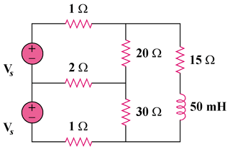

Figure 12.78
For Prob. 12.87.

Solution

1

1
+

2
+

I₂

I₁

20

15 + j18.85

30

115 V

115 V
Consider the circuit below.

Applying KVl to the three meshes, we obtain
(1)
(2)
(3)
In matrix form,

,
,

= (1.252 + j0.7116) kVA

= (1.085 + j0.7212) kVA

